Z-Score Standardization

Definition
# Source: AI Source: Provided by: [Data Path: Persons Table -> ID Column: 1, Name_En Column: Motasem Essam] -> From: [Chatgpt (GPT‑5 Mini)] on [12/10/2025]
Z-Score Standardization (also called Standard Score Normalization) is a data scaling technique that transforms numerical values so that the dataset has a mean of 0 and a standard deviation of 1.
This method is commonly used in data preprocessing for machine learning and statistical analysis.

Formula
# Source: AI Source: Provided by: [Data Path: Persons Table -> ID Column: 1, Name_En Column: Motasem Essam] -> From: [Chatgpt (GPT‑5 Mini)] on [12/10/2025]
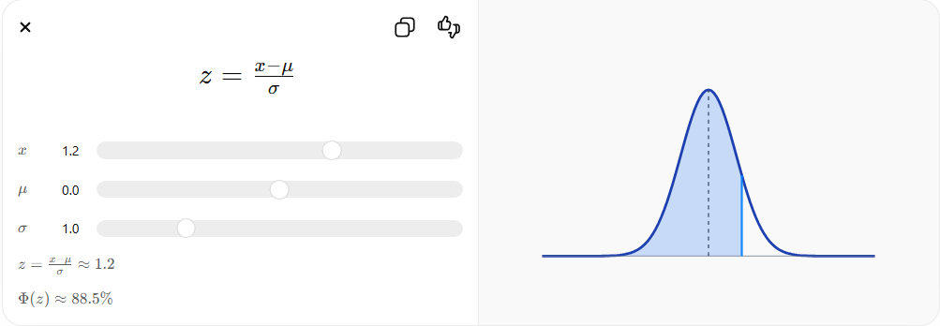
Where:
- $x$= original value
- $μ$= mean (average) of the dataset
- $σ$= standard deviation of the dataset
- $z$= standardized value (Z-score)

Key Idea
# Source: AI Source: Provided by: [Data Path: Persons Table -> ID Column: 1, Name_En Column: Motasem Essam] -> From: [Chatgpt (GPT‑5 Mini)] on [12/10/2025]
Z-Score Standardization measures how many standard deviations a value is from the mean.
- Positive value → above the mean
- Negative value → below the mean
- 0 → exactly equal to the mean

Example
# Source: AI Source: Provided by: [Data Path: Persons Table -> ID Column: 1, Name_En Column: Motasem Essam] -> From: [Chatgpt (GPT‑5 Mini)] on [12/10/2025]
Suppose:
- Mean $(μ)=60$
- Standard Deviation $(σ)=10$
- Value $(x)=70$
Calculation:
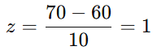
[
z = \frac{70 - 60}{10} = 1
]
This means the value 70 is 1 standard deviation above the mean.

Example Table
# Source: AI Source: Provided by: [Data Path: Persons Table -> ID Column: 1, Name_En Column: Motasem Essam] -> From: [Chatgpt (GPT‑5 Mini)] on [12/10/2025]
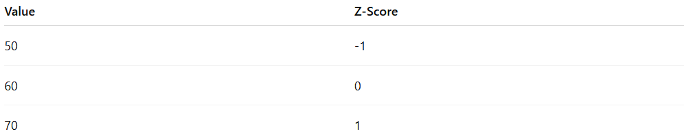
Value | Z-Score
50 | -1
60 | 0
70 | 1

Advantages
# Source: AI Source: Provided by: [Data Path: Persons Table -> ID Column: 1, Name_En Column: Motasem Essam] -> From: [Chatgpt (GPT‑5 Mini)] on [12/10/2025]
- Works well when data follows a normal distribution
- Less affected by outliers compared to Min-Max normalization
- Widely used in algorithms like Logistic Regression, SVM, and PCA

Disadvantages
# Source: AI Source: Provided by: [Data Path: Persons Table -> ID Column: 1, Name_En Column: Motasem Essam] -> From: [Chatgpt (GPT‑5 Mini)] on [12/10/2025]
- Does not limit values to a specific range (like 0–1)
- Requires calculating the mean and standard deviation

